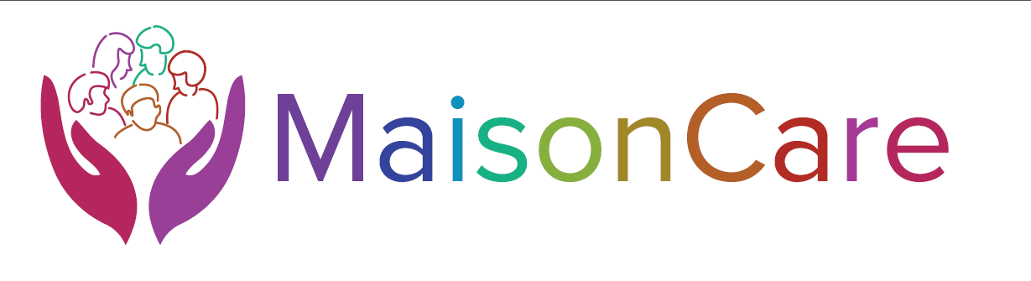

Equality Monitoring Form

Why should you complete this form?
Maison Care Ltd works hard to ensure that people are not discriminated against. The information you give us, helps us to provide fair and equal opportunities to our employees. It also helps us to deliver the service that reflects our community. We have a legal duty to ensure that our services are fully inclusive and accessible to everyone. To make that possible we have to be aware of your different requirements.

Under the Equality Act 2010 people are protected from unlawful discrimination if they have the following protected characteristics; age, marriage and civil partnerships, race, religion and belief, sex, gender reassignment, sexual orientation, disability and pregnancy and maternity.

The information you give us will help us to make adjustments based on fact, rather than assumption, and importantly this ensures that money is being spent on the correct things.

It is sensible to feel protective or cautious about disclosing any personal information, but feel assured that this information will be used for monitoring purposes only and not for any other purpose. It is completely confidential and any data we hold will be stored separately from any data that could identify you personally.

Please indicate your answer with a | x

What is your date of birth? DAY / MTH / YEAR

What is your race? (This includes colour, nationality, including citizenship, and ethnic or national origins.)

White | British |  | Mixed multi ethnic | White & Black Caribbean
 | Irish |  |  | White & Black African
 | Polish |  |  | White & Asian
 | Lithuanian |  |  | Arab
 | Other, please state |  |  | Other, please state
Asian or  Asian British | Indian |  | Chinese or other ethnic groups | Chinese
 | Pakistani |  |  | Philippine
 | Bangladeshi |  |  | Vietnamese
 | Nepali |  |  | Thai
 | Other, please state |  |  | Other, please state
Black | Caribbean |  | Gypsy & Traveller | Irish
 | African |  |  | Romany
 | British |  |  | Other, please state
 | Other, please state
Any other ethnic or nationality background not listed, please state

What is your religion or belief?

None |  | Christianity |  | Judaism |  | Buddhism
Islam |  | Hinduism |  | Sikhism |  | Other

What is your relationship status? (*Delete as appropriate)

Married/Separated * |  | Civil Partnership
Single/widowed/divorced * |  | Live with partner/Other *

What is your gender identity?

Female |  | Female to Male transgender
Male |  | Male to Female transgender

What is your sexual orientation?

Heterosexual  (people of opposite sex) |  | Bisexual  (people of either sex)
Gay  (both men) |  | Lesbian  (both female)

Pregnancy and Maternity (The Equality Act 2010 protects women who are pregnant or have given birth within a 26 week period.)

Are you pregnant at this time?
Have you recently given birth (within 26 week period)

Do you consider yourself to have a disability? (The Equality Act 2010 state a person has a disability if they have a physical or mental impairment which has a long term (12 month period) or substantial adverse effects on their ability to carry out day to day activities.)

Physical impairment (please state) |  | Sensory impairment (please state)
Mental health condition |  | Learning disability or difficulty
Long term illness (please state) |  | Other, please state

To help us measure whether people from all parts of our community are receiving equal treatment, can you please tell us your postcode

Date this form was completed

Finally , Maison Care Ltd would like to thank you for completing this form.

